Windsor Castle ~Jericho Rd~ Cemetery
Visited by Members of
Grave Site Survey Task Force (GSSTF)
Under the Auspices of
Isle of Wight County Historical Society (IWCHS)
November 28, 2003 – February 22, 2004 - February 29, 2004

This cemetery is of great historical significance since the property is thought to be the residence of Smithfield’s founder Arthur Smith or his descendents. Photographs were taken both inside and outside the house as well as the cemetery. Some of these photographs were used to develop panoramic views (view sheds) from the windows around the house as well as outside views of the property.

A unique finding in the cemetery was the discovery of a slate-topped burial vault or casket; however, there were no marking to indicate the person (or persons) buried within.

Any text within the “[ ]” is a comment about the tombstone inscription, ex., [fs] indicates a footstone inscription. Throughout the transcribing process, an attempt was made to preserve the, ‘look and feel’ of the original inscriptions as regards word spacing, arrangement, and possible misspellings.

Please address your comments/corrections to: albert.b@charter.net or epowellsr@aol.com.

Thanks to Jeff Stark for the following information on Windsor Castle cemetery … it is being submitted in its entirety.

Cemetery at Windsor Castle, Smithfield, VA

Location: Approximately 200 yards NE of the main house known as Windsor Castle, on Jericho Road, across a field and inside a tree line, on a rise overlooking Cedar Creek. Visited on November 28, 2003 and again by IWCHS members on February 22 and February 29, 2004. Members cleared brush and searched for evidence of graves other than those marked by gravestones.

Cemetery is very overgrown with small trees and heavy vines, also numerous downed and decaying trees as the result of past storms and Hurricane Isabel, which struck in mid-September, 2003.

Marked Graves:

1. Large (approximately 40” wide by 50” tall) granite marker previously knocked over from granite base … Masonic emblem at top of marker.

Arthur Smith
Son of
Arthur Richard
and Virginia Cowper

WHITEHEAD
Aug. 26, 1882 – Dec. 25, 1921

2. Standing stone, marble, excellent condition, carved rope motif border, “tree of life” in circle at top center, located 15 feet south of #1 above. In front of stone, brick vault caved in, about 3 feet deep, 7 feet long, filled with leaves, earth and debris.

SACRED
To the memory of
RICHARD GOODWIN
Who died near
Little Rock, Ark.
June 14, 1870
Born in Isle of Wight
Co. Va, March 22, 1830
He was a member of the
M.E. Church in the full
enjoyment of religion
and died trusting Christ
----------------------------
God gives, he takes, he will re-
store, he doeth all things well.
Erected by his mourning
Widow E.M.A. Goodwin

Reverse of stone: J. Mulholand
Ports. Va

R.G. [fs]

3. Unmarked grave approximately 6 feet to northeast of grave #2, dimensions about 3 feet wide by 7 feet long, brick vault, covered on surface with mortar, about one foot below surface of the earth, located by probing, no visible identification.

4. Unmarked grave about 3 feet to the northeast of grave #1, located by probing and then partially excavated. Appears to be slab of slate, approximately 3 feet wide by 7 feet long and 2 inches thick. Top of slate slab about 2 feet beneath surface of the earth, 10-inch tree with large root system right on top of grave. Members partially uncovered the top surface of the slab at the head and foot of the grave, but no visible markings noted.

NOTE: One of these graves may belong to Mrs. E.W. Cocke, “…consort of the late Lt. Wm. Henry Cocke, died at Smithfield Sunday the 26th of May 1861 in the 61st year of her age. Daughter of James and Elizabeth Smith Johnston.” This is from a Cocke family bible per Helen Haverty King.

Substantiating Evidence: IOW census of 1850 lists Cocke, Eliza W., white female aged 51, and Marina Cocke, white female aged 25.

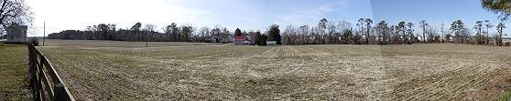
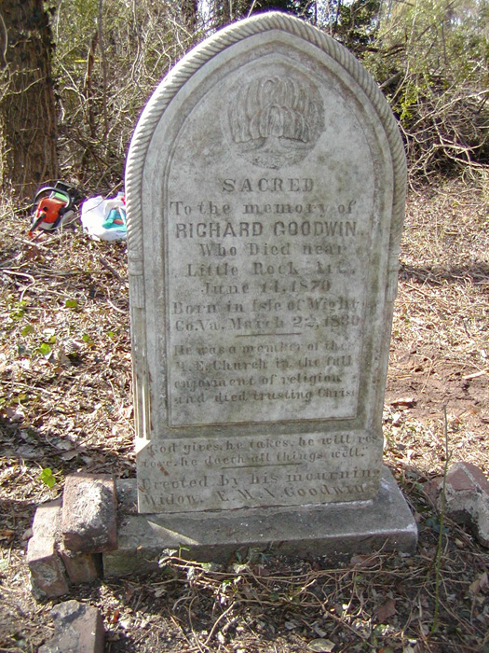 | 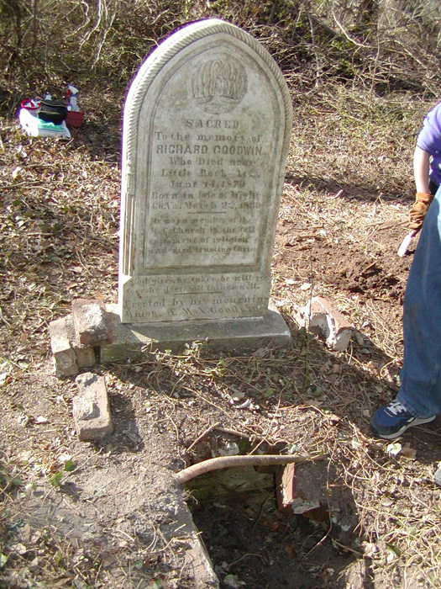
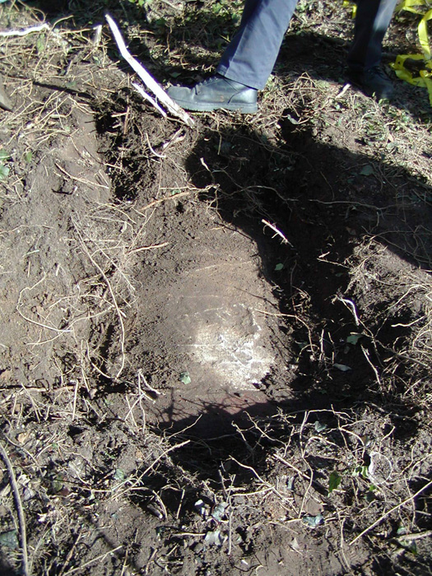 | 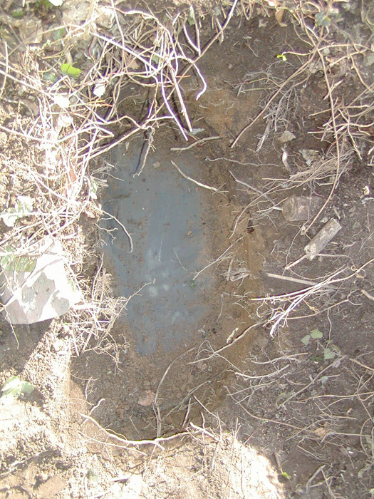
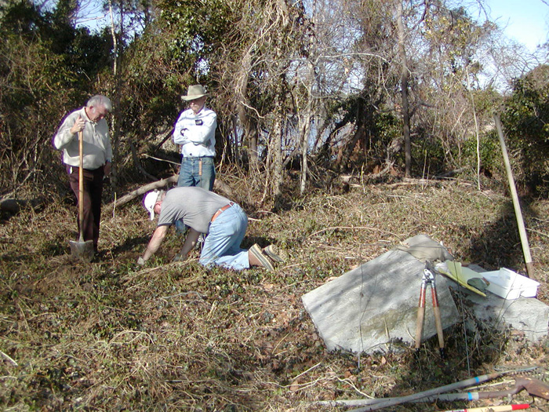 | 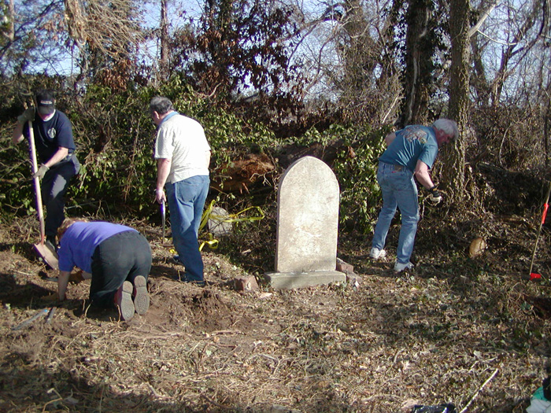
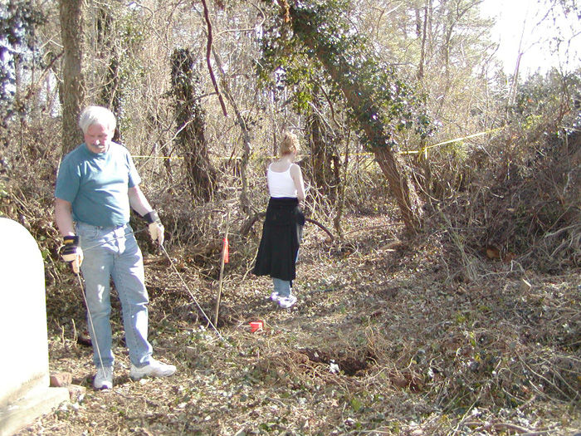 | 