Young ~Turner Rd~ Cemetery
Transcribed by members of the
Grave Site Survey Task Force (GSSTF)
Under the Auspices of
Isle of Wight County Historical Society (IWCHS)
Visited March 29, 2006

This cemetery was initially identified as Turner ~Turner Rd~ cemetery; however, what supposedly was a cemetery was not the actual cemetery. In all probability, it was either a small building foundation or an animal pen of sorts. The actual cemetery was discovered later and this report is a written record of the later visit. A Ms. Elsie Cox transcribed this cemetery in 1972; her report is included in the Southampton County Roots web as IW-23 and is reproduced in this report as well (see Note # 1).

Any text within the “[ ]” is a comment about the tombstone inscription, ex., [fs] indicates a footstone inscription. Throughout the transcribing process, an attempt was made to preserve the, ‘look and feel’ of the original inscriptions as regards word spacing, arrangement, and possible misspellings. GSSTF members were careful not to damage tombstones or artifacts during the transcription process.

Please address your comments/corrections to: albert.b@charter.net or epowellsr@aol.com.

 | Inscription |  |  | Inscription
 | In  Memory of  SARAH YOUNG,  Wife of  NATHANIEL YOUNG;  Who died the 18th, day  of December 1813,  Aged 31 years,  7 mon –  ths and 18 days |  |  | [another vault type grave – no markings]
 | [brick residue in depressions, possibly 3 other graves]

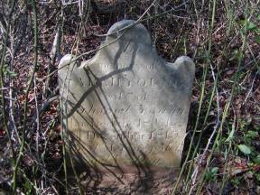 | 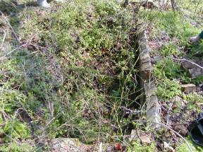
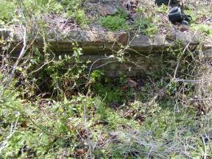 | 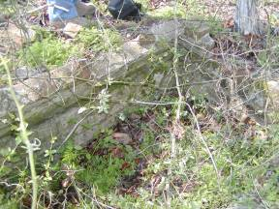
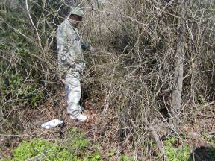 | 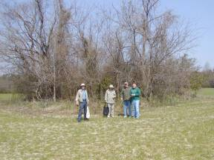
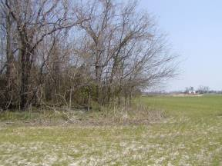 | 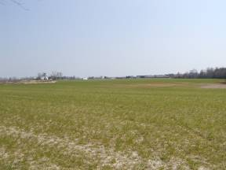

Notes:
(1) Elsie Cox’s report from 1972:
IW-23
YOUNG CEMETERY
LOCATED 1 1/2 MILES NORTH OF BENN'S CHURCH, VA. ON HIGHWAY 10; THEN LEFT ON 644 TO THE FIRST FARM ON RIGHT. FARM OWNED BY JONES TURNER (1936). CEMETERY IS IN A FIELD TO THE LEFT HOUSE.
WPA RECORD COPIED BY FLORENCE JORDAN (1936)
INFORMATION BY MRS. JESSE MINTON, SMITHFIELD, VA.
REVISITED BY ELSIE H. COX (04-28-1972)
Only an empty grave at this cemetery. Bricks from the vault lying
around. No stone remains. Cemetery overgrown.

Sarah [West] Young
wife of
Nathaniel Young
who died on the 18th day of
December 1813
Aged 31 years.

[Nathaniel Young was a Clerk of Court of Isle of Wight Co., Va. for a number of years. Nathaniel and Sarah West Young were married 03-30-1803 (Marriage Register 1772-1853, Isle of Wight
Count Clerk's office) I was told that the Youngs formerly lived
on this farm before moving to "Oak Level' on highway 258 near Isle of Wight. Bodies in the Young family cemetery at "Oak Level" were moved to

