Nosworthy ~Yellow Rock Ln~ Cemetery
Transcribed by members of the
Grave Site Survey Task Force (GSSTF)
Under the Auspices of
Isle of Wight County Historical Society (IWCHS)
Visited June 22, 2005 & February 19, 2006

A selection of shaving foam, water, or talcum powder was used to improve the legibility of the inscriptions on the older tombstones. Afterwards, a clean water spray was used to remove any residue. GSSTF members were careful not to damage tombstones or artifacts during the transcription process.

Any text within the “[ ]” is a comment about the tombstone inscription, ex., [fs] indicates a footstone inscription. Throughout the transcribing process, an attempt was made to preserve the, ‘look and feel’ of the original inscriptions as regards word spacing, arrangement, and possible misspellings.

Please address your comments/corrections to: albert.b@charter.net or epowellsr@aol.com.

 | Inscription |  |  | Inscription
 | In Memory of  Miss MARTHA NOSWORTHY  who departed this life  In April 1840  In the 84th year of her age.  This perishable tribute of respect  and affection is here placed.  Woman  Not she with traitorous kiss her Saviour stung  Not she denied Him with unholy tongue:  She when Apostles fled could daggers brave  Last at the cross and earliest at the grave.  Rob.^{t} Dalrymple  Norfolk. |  |  | Sacred  To the Memory of  M. FRANCES KING  Who departed this life  on the 13th day of May 1841  in the 75th year of her age.  Rob.^{t} Dalrymple  Norfolk

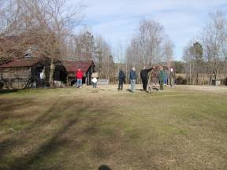 | 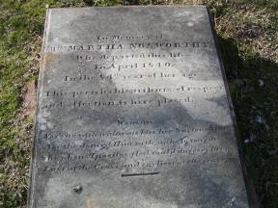
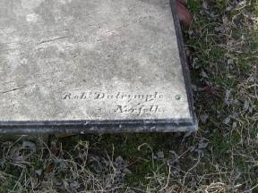 | 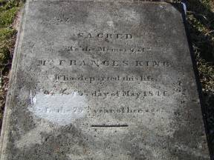
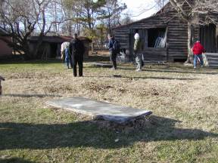 | 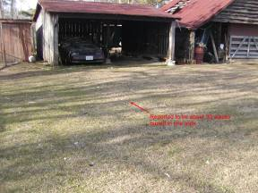
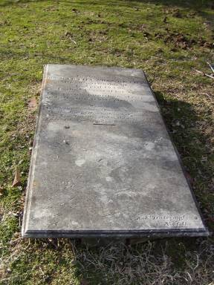

Notes:
(1) In the picture above with the red arrow and text … the property owners reported that there were about 30 slaves buried in this area; however, there were no visible markers and shallow probing with metal rods did not reveal any artifacts such as caskets or other identifiable material.

